Host Your Resume on AWS EC2 with a CI/CD Setup Using GitHub Actions
This article helps you understand how you can automatically deploy your code to AWS EC2 from GitHub
- Step1: Create an EC2 Instance and Download the Key Pair.
- Step2: Create Secrets in GitHub for the Repository
- Step3: Creating your first workflow
- Step4: Testing
Creating your first workflow
Create a .github/workflows directory in your repository on GitHub if this directory does not already exist.
In the .github/workflows directory, create a file named github-actions-ec2.yml.
Now your github-actions-ec2.yml should be present in .github/workflows/github-actions-ec2.yml in your repository
Start your file by defining jobs, jobs are the steps that you can define and see individual status reports when you see the logs in your Actions tab
jobs:
deploy:
name: Deploy to EC2
runs-on: ubuntu-latest
In the above block we have defined our job with name Deploy to EC2 and enforced it to run on latest Ubuntu by runs-on: ubuntu-latest line
Now, we need to checkout the pushed code to the runner by using a predefined action named actions/checkout@v2. The code responsible for this step should look like the following
steps:
- name: Checkout the files
uses: actions/checkout@v2
Now, we are deploying the code to the server, in order to to do this we need to access the EC2 using ssh and perform rsync form the runner. For this we are going to use another GitHub action easingthemes/ssh-deploy
- name: Deploy to Server 1
uses: easingthemes/ssh-deploy@main
env:
SSH_PRIVATE_KEY: ${ { secrets.EC2_SSH_KEY }}
REMOTE_HOST: ${ { secrets.HOST_DNS }}
REMOTE_USER: ${ { secrets.USERNAME }}
TARGET: ${ { secrets.TARGET_DIR }}
Note: You need to put the double parentheses together; I had to leave a space because my code formatter refuses to print it (:facepalm)
You need to fill in the secrets using GitHub Secrets that you can add in your repo, read GitHub Secrets
- EC2_SSH_KEY: This will be your .pem file which you will use to login to the instance
- HOST_DNS: Public DNS record of the instance, it will look something like this ec2-xx-xxx-xxx-xxx.us-west-2.compute.amazonaws.com
- USERNAME: Will be the username of the EC2 instance, usually ubuntu
- TARGET_DIR: Is where you want to deploy your code.
Once you add all these information your repo will look like thisGitHub Secrets
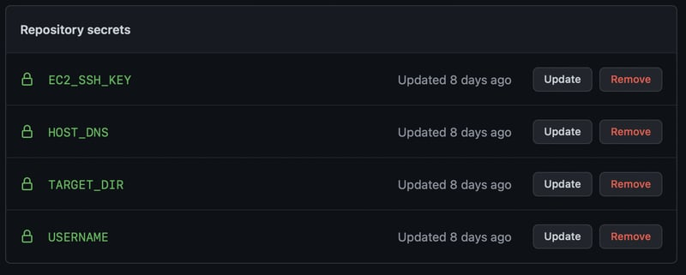
Trigger deployment only on push to master branch
Add the following code so that your actions only run when you push to main branch.
on:
push:
branches:
- main
The final .github/workflows/github-actions-ec2.yml should looks like the following
name: Push-to-EC2

# Trigger deployment only on push to main branch
on:
push:
branches:
- main

jobs:
deploy:
name: Deploy to EC2 on master branch push
runs-on: ubuntu-latest

steps:
- name: Checkout the files
uses: actions/checkout@v2

- name: Deploy to Server 1
uses: easingthemes/ssh-deploy@main
env:
SSH_PRIVATE_KEY: ${{ secrets.EC2_SSH_KEY }}
REMOTE_HOST: ${{ secrets.HOST_DNS }}
REMOTE_USER: ${{ secrets.USERNAME }}
TARGET: ${{ secrets.TARGET_DIR }}

- name: Executing remote ssh commands using ssh key
uses: appleboy/ssh-action@master
with:
host: ${{ secrets.HOST_DNS }}
username: ${{ secrets.USERNAME }}
key: ${{ secrets.EC2_SSH_KEY }}
script: |
sudo apt-get -y update
sudo apt-get install -y apache2
sudo systemctl start apache2
sudo systemctl enable apache2
cd home
sudo mv * /var/www/html

